36.7: The diffraction minima are located by 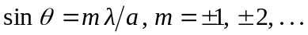
no solution for larger

